C.W. Mills Acknowledgment Project

Henry Hyunsuk Kim

Mentored by Bob Nachbar

WWS 2019

**If my data is imported and Iconized**, I am asking that said data belongs solely to Henry H. Kim

Currently, the Excel file looks like this:

|  |  |  |  |  |  |  |  |
| --- | --- | --- | --- | --- | --- | --- | --- |
| Year | Book Title | Sender  (Author) | Recipient  (Friend) | A’s Current Academic Institution | A’s UG | A’s PhD | Publisher |

Bob, if missed anything below, let me know. And please feel free to make suggestions – I value your feedback.

|  |  |
| --- | --- |
| **Tasks** | **Deadlines (11:59 P.M.)** |
| **1. Preparing the data**  A. Remove typos  B. Adjust for missing values  C. Adjust for co-winners  D. Adjust for different spellings of the same person  E. Adjust for one known missing year (book)  F. Adjust for co-authors (multiple edges?)  E. Change Columns accordingly for future analysis | Tues. July 2nd |
| **2. SNA**  A. Create an appropriate graph (sociogram)  B. Ascertain which SNA metrics are appropriate  C. Remove isolated nodes from the central graph  D. Use the years to create a time series (1964 – 2017)  E. Which nodes or patterns (associations) emerge? | Fri. July 4th |
| **3. Tests (this is a heuristic list)**  A) Dunbar’s Rule N = 150  B) Zipf’s Kth is 1/k of the 1st number  C) Sarnoff’s V = n  D) Odlyzko’s n log(n)  E) Metcalfe’s V = n^2  F) Reed’s V = 2^n  G) Feigenbaum (x3-x2)/(x2-x1) = F Constant  Other rules/laws whereby I really start rambling into Neverland  H) Cellular Automata?  I) Agent Based Modeling?  J) Self-Organized Criticality?  K) Phase Transitions?  L) Fractal Geometry  N) Built-in Mathematica tests?  O) Machine Learning tests? | Wed. July 7th |
|  |  |
|  |  |
| **4. Visualizations**  A. Highlight Key vertices or edges  B. A Manipulate Function of time | Tues. July 9th |
| **2 Minute Presentations** | **WED July 10th 6-10 PM** |

Though this project centers on SNA, there are (much) larger contexts.

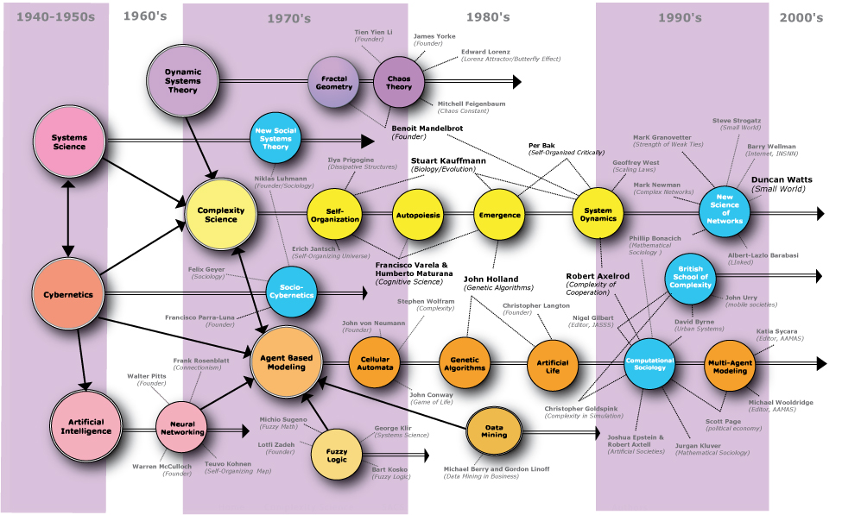

Castellani and Hafferty (2009: xi)